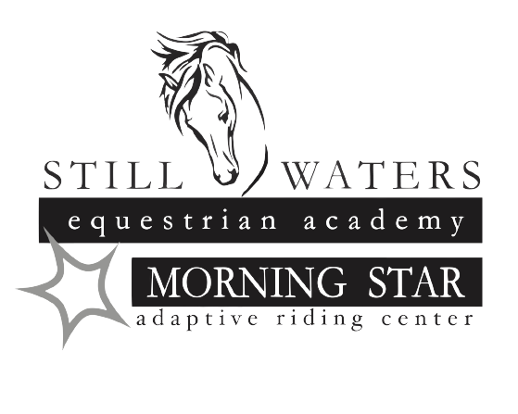

**PARTICIPANT APPLICATION/RELEASE OF LIABILITY**

**Lessons are by appointment only. Lesson prices are as follows**

$60.00 for private lessons $50 for group lessons of 2 or more students $40 for ½ hour private lesson

**Student Requirements**

All riders **must wear an equestrian helmet**. If you do not have one, helmets are available to borrow. Proper footwear and attire must be worn. Riding shoes or boots with a smooth sole approximately a one-inch heel for the safety of the rider. Long pants are a must.

I AGREE TO ASSUME FULL LIABILITY FOR MY CHILD/CHILDREN IN CASE OF ACCIDENT/INJURY. I WILL NOT HOLD Still Waters Equestrian Academy OWNERS/EMPLOYEES RESPONSIBLE IN CASE OF ACCIDENT/INJURY. I understand it’s the nature of large animals such as horses/ponies to occasionally be unpredictable, especially when startled by other animals or circumstances not easily anticipated. There is an INHERENT RISK IN riding/attending any horse/pony which must be ASSUMED BY ME ON BEHALF OF MY CHILD/CHILDREN. Horseback riding is a PHYSICAL ACTIVITY, SO I WILL SEND MY CHILD/CHILDREN IN good health: e.g. NO broken bones, NO contagious diseases, and NO ALLERGIES TO HORSES. MY CHILD/CHILDREN WILL DRESS TO RIDE/ATTEND to HORSES/PONIES, per Instructor’s Directions.

***Participant’s Full Name*** _______________________________________________________________Date_______________

Date of Birth: __________________________________________________ Gender _____________

Mailing Address ____________________________________________________________________

City ________________________________________ State _____________ Zip _________________

Phone#: Home: (____)________________Cell: ( ___)________________Work: ( ___)____________

Participant’s email_____________________________________________

***Primary Contact Person/ Legal Guardian***

Name(s):__________________________________________Email:______________________________

Phone#: Home:(____)______________ Cell:(___)__________________Work:(___)______________

***Other Contact Person***

Name(s):__________________________________________Email:______________________________

Phone#: Home:(____)______________ Cell:(___)__________________Work:(___)______________

**RELEASE OF LIABILITY**

***(This form must be signed and updated annually if the individual wishes to participate in any MORNING STAR program)***

**Name of Participant: ____________________________________________________________________________**

I acknowledge the risks and potential for risks of horseback riding. However, I feel that the possible benefits to myself/my son/my daughter/my ward are greater than the risk assumed. I hereby, intending to be legally bound, for myself, my heirs and assigns, executors or administrators, waive and release forever all claims for damages or otherwise against Still Waters Equestrian Academy, Morning Star Riding Center, its Board of Directors, Officers, Instructors, Therapists, Aides, Volunteers and/or Employees for any and all injuries and/or losses I/my son/my daughter/my ward may sustain while participating in equestrian programs at Morning Star Riding Center.

**WARNING:**

***Under Nebraska Law, an equine professional is not liable for an injury to or the death of a participant in equine activities resulting from the inherent risks of equine activities pursuant to sections 25-21, 249 to 25-21,253.***

Yes, I would like above named person to participate in programs at Still Waters Equestrian Academy. I understand and agree that Still Waters Equestrian Academy, its Board of Directors, Officers, Instructors, Therapists, Aides, Volunteers and/or Employees will have NO LIABILITY in the event of any accident that may occur.

No person can be accepted for participation in at Still Waters Equestrian Academy until this form has been completed by the parent(s)/ guardian. If the person is of legal age (18), he or she may complete the form if he or she is legally competent to do so. All activities will be under supervision and, although reasonable effort will be made to avoid any accident, Still Waters Equestrian Academy will have NO LIABILIITY.

I acknowledge that any involvement with horses is a high-risk activity. I have read this notice and release of liability and fully understand and agree with its content.

**AGREED: ____________________________________________________________________________________________**

Signature of Adult Participant or Parent/Guardian if under 18 or have a guardian Date

**PHOTO RELEASE**

I ❏ DO OR ❏ DO NOT consent to and authorize the use and reproduction Still Waters Equestrian Academy of any and all photographs and audio/visual materials taken of me for promotional material or for any other use for the benefit of the program, including but not limited to: social media, publications and marketing.

**_________________________________________________________________________________________________________**

Signature of Adult Participant or Parent/Guardian if under 18 or have a guardian Date

Still Waters Equestrian Academy

18221 S. 68TH St.

Hickman, NE 68372