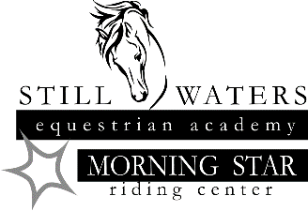
Still Waters Dressage Schooling Show

Stabling is Jump Out - email laura@stillwaterseq.org for availability of day stall/outside pen, $15 per horse.
Attire: Attire appropriate for Schooling Shows is expected. Helmets are required for all riders, no exceptions.
No Dogs Permitted on the Property
Ride Times will be posted on the Still Waters Equestrian website – www.stillwaterseq.org
PRIZE LIST: Ribbons will be awarded through 6th place by division
Refunds: Office Fee is non-refundable. Entries with written cancellation on or before closing date will receive 100% refund.
Signature & Waiver of Liability
Under Nebraska law, an equine professional is not liable for an injury to or the death of a participant in equine activities resulting from the inherent risks of equine activities, pursuant to section 25-21,249 to 25-21,253, Nebraska Revised Statutes.
I AGREE to release, indemnify and hold harmless the owners of Still Waters Equestrian Academy, and their agents, instructors, and volunteers from and against any and all loss, liability, or damage arising from, because of, or in connection with my participation in this competition. I also hereby agree to release, indemnify, and hold harmless the management of the competition, its agents, and volunteers from and against any and all loss, liability, or damage arising from, because of, or in connection with my participation in this equine event or competition.
I have read and understand the rules for the competition, as outlined in the prize list, and agree to abide by them. I understand the show management is authorized to make decisions based on those rules, and their decisions are final. If I am a parent or legal guardian of a participant under the consent to the child’s participation, agree to all the above provisions, and agree to assume all the obligations of this release on the child’s behalf. By my signature, I acknowledge that I have read and understand the foregoing Liability Release.
_______________________________________________________ ____________________________ Rider Date _______________________________________________________ ____________________________ Owner Date _______________________________________________________ ____________________________ Parent or Guardian (if rider under age 19) Date

